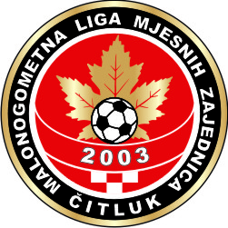
MNL MZ OPĆINE ČITLUK 2022

POPIS IGRAČA I VODSTVA MOMČADI

MZ_______________________________________
dana:________________2022.

Broj dresa igrača: Ime i Prezime igrača:

_____________________________________________________________________

_____________________________________________________________________

______________________________________________________________________

______________________________________________________________________

______________________________________________________________________

______________________________________________________________________

_______________________________________________________________________

_______________________________________________________________________

_______________________________________________________________________

_______________________________________________________________________

_______________________________________________________________________

_______________________________________________________________________

Voditelj/trener momčadi:________________________________

Predstavnik momčadi:_____________________________ ______________________
/p o t p i s/
Fizioterapeut:__________________________

